Class Number Name

Machine number Experiment date Report date

**Experiment topic:**

Experiment 3 Simple queries (1)

1. **Experiment objectives**

1）Master the solution of attaching a database into the lab environment.

2）Master the method of using SELECT.

3）Master the methods of managing simple queries.

**2. Experimental content**

4.1 Attaching the projemp database

1) Download the projemp database file (projemp.mdf) from the Lab Resources

folder on Blackboard to your download folder.

2) Copy & Paste projemp.mdf from your download folder to

C:\Program Files\Microsoft SQL Server\MSSQL14.SQLEXPRESS\MSSQL\DATA

In general, always use ‘Copy & Paste’ when moving database files - do NOT use

‘Drag & Drop’. If necessary, click ‘continue’ if you are asked for administrator

permissions.

3) Open SQL Server Management Studio (SSMS) and connect to the server.

4) In Object Explorer, right click on Databases, and click ‘Attach…’ on the

pop-up menu.

5) Click ‘Add…’ on the dialogue box, select projemp.mdf when the list of

available databases appears, then click ‘OK’ on both dialogue boxes to

attach the database.

6) Expand the Databases tab in Object Explorer. projemp should now be

attached and available for use.

7) Use database file projemp on SQL Server - Execute USE projemp; in a New

Query window

Click on New Query on the top menu to create a new query.

USE projemp;

GO Placed before each query ensures the correct database is current 4.2 Complete the following queries using SELECT clause

1) Display all the records in the EXP table;

2) Get the employee names and ages of those employees in department number

'd1'. (11 records)

3) Get the employee number and name of all employees aged above 30 in

department number ‘d2’ (1 records)

NOTE: Values of a character datatype attribute (e.g., dno) must be shown in

inverted commas (single not double), whereas numeric datatype attributes are not.

4) Get the names of employees earning less than £20,000 or more than £30,000.

(13 records)

5) How many employees are in department number 'd3'? (1 records)

6) Get the total salary of all employees in department number ‘d1’ (adds up all

salaries in department ‘d1’ ) (1 records)

7) Get the employee names and their salaries in ascending order of salary.

NOTE: ASC is the default value if ASC or DESC is not entered; DESC sorts in

descending order

Try changing ASC to DESC and changing the ORDER BY attribute to ename

8) Get the employees who have salaries of £18,000 or £20,000 (Use of the IN

predicate) (2 records)

9) Get the names of employees who earn a salary above £25,000. (10 records)

10) Get the names of employees who earn a salary above £25,000 and are

in department number 'd1'. (6 records)

11) What is the average age of employees in department number 'd2'?(29)

12) List the names, salaries and ages of all employees in department number

'd1’ in descending order of age (oldest to youngest).(11 records)

13) How many employees have a salary greater than £20,000 and are in

department number 'd1?'(9)

**3. Experiment procedure**

According to the task, list the task description, the screenshot of the solution process and the screenshot of the running result.

3.1 Task description

The task solution and results

4.1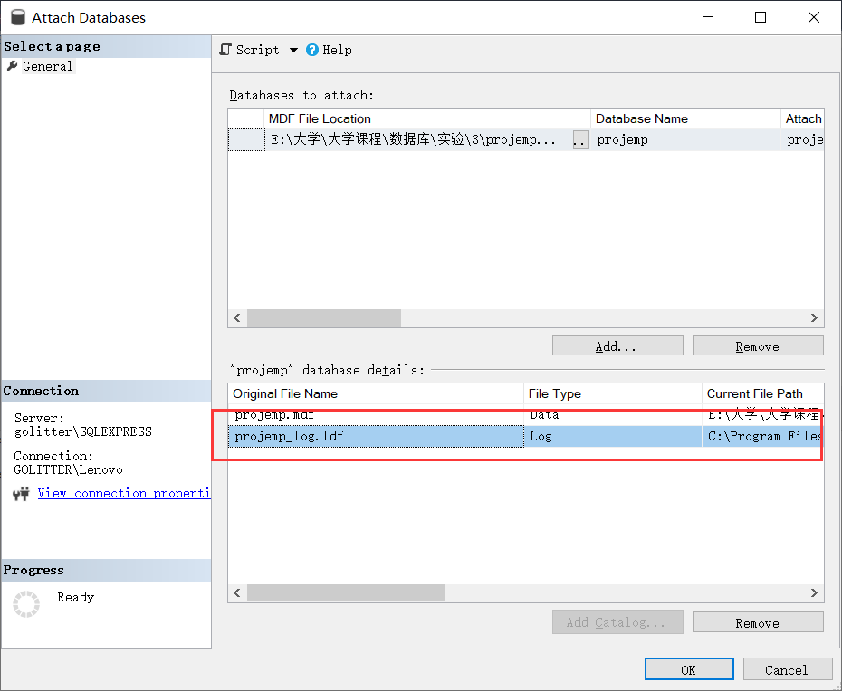

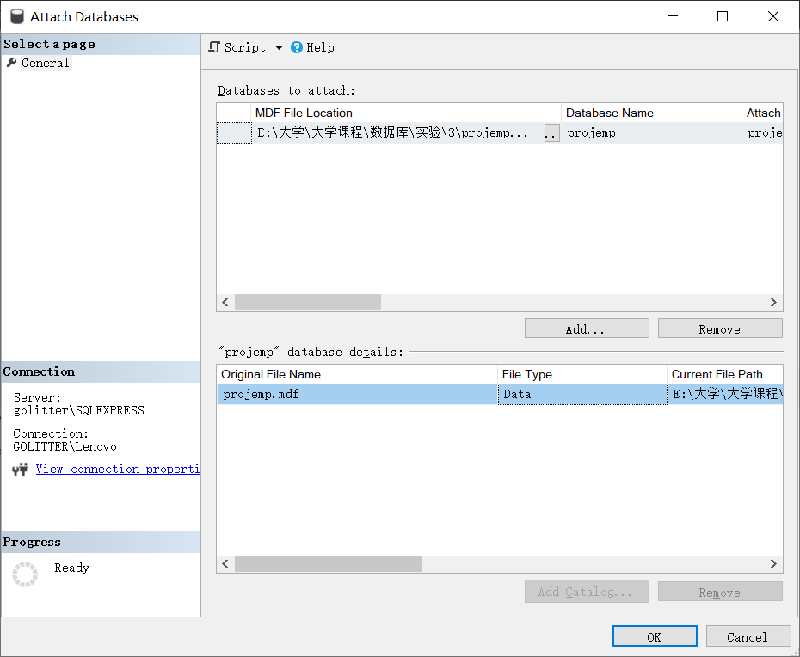

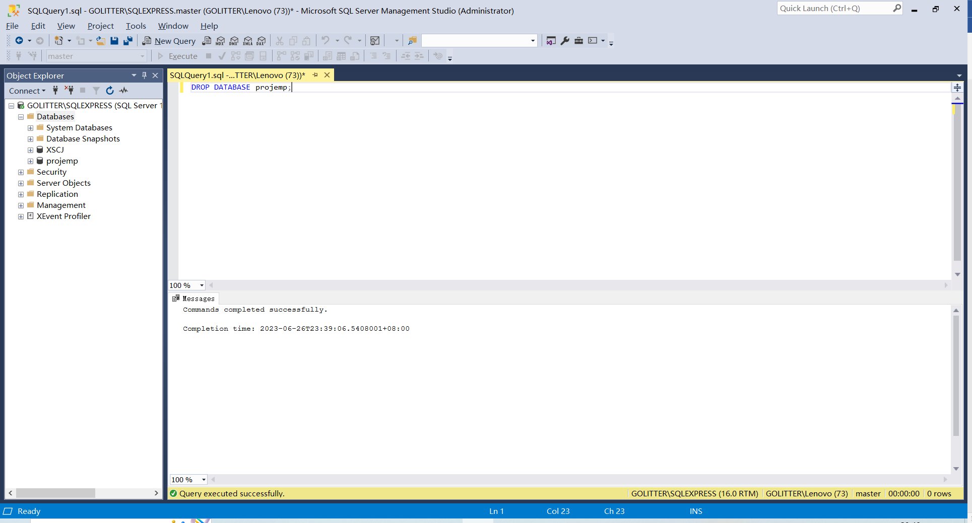

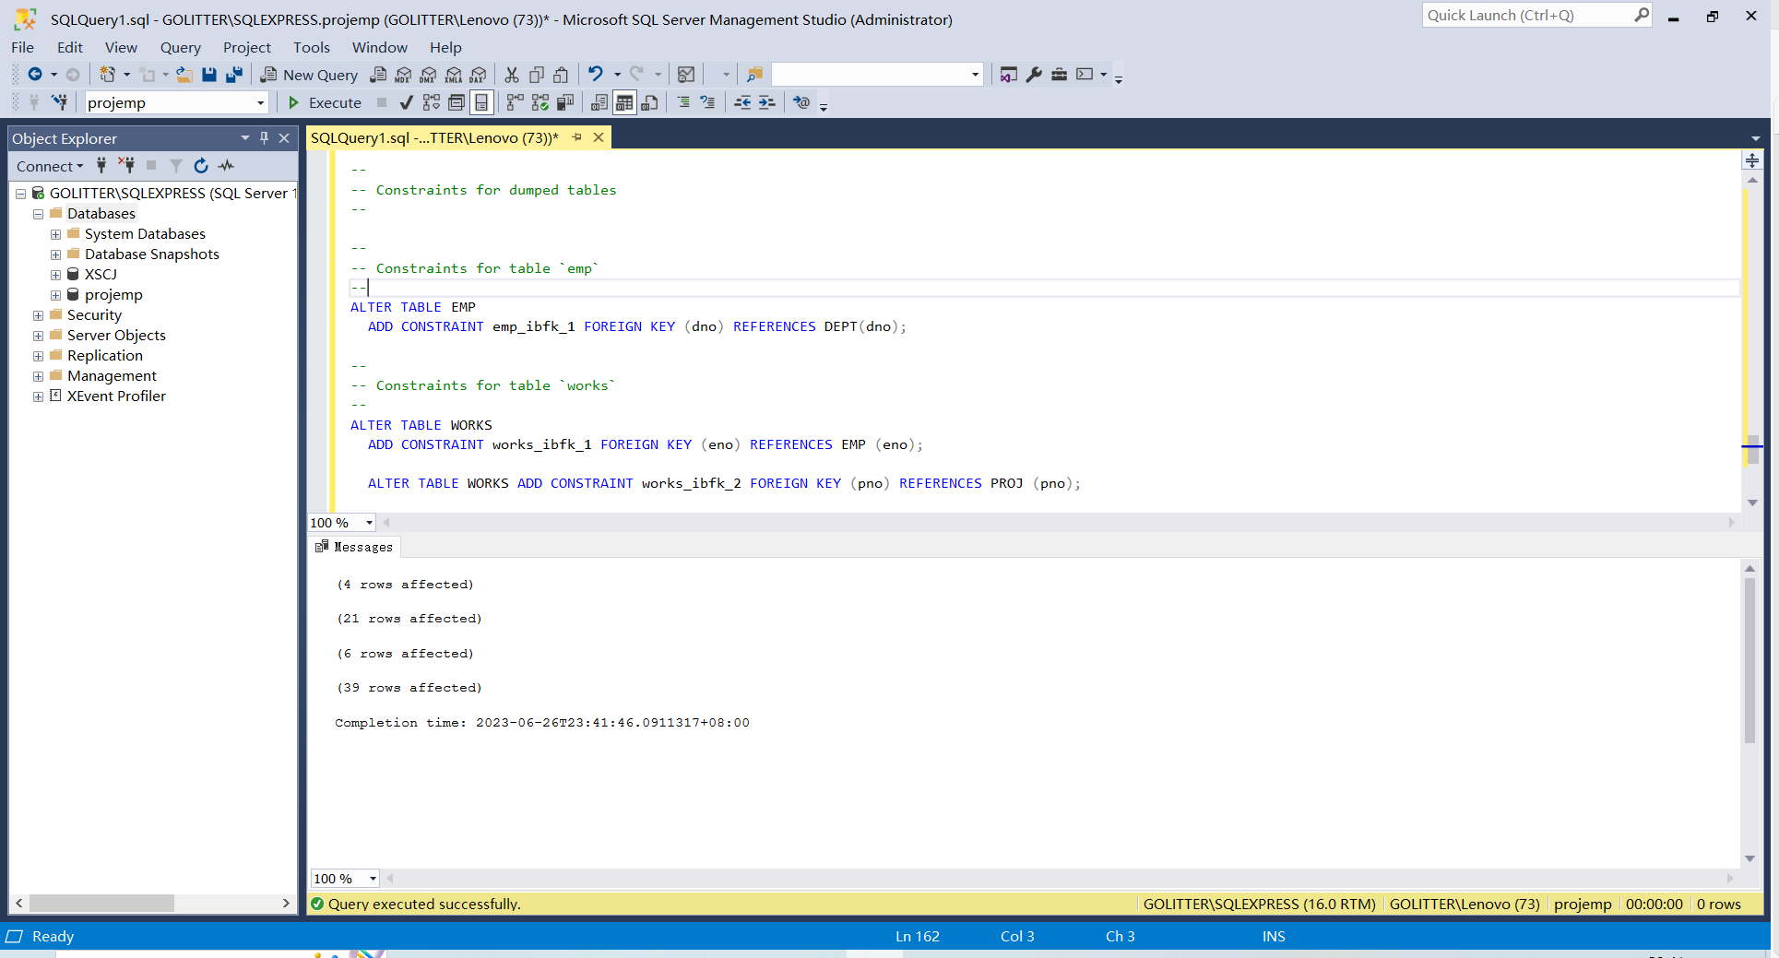

4.2

1）



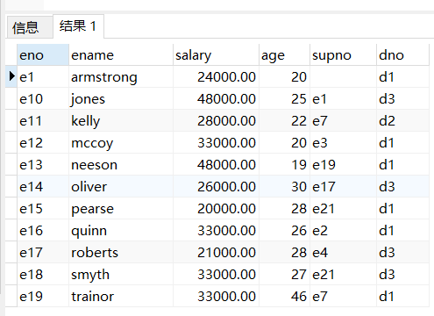

2）

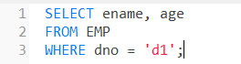

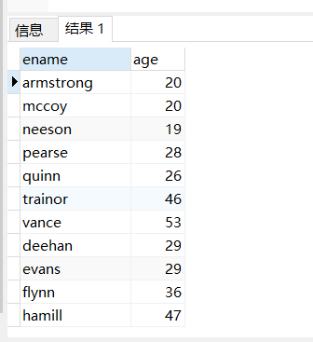

3）

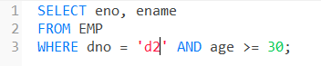

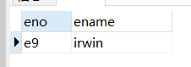

4）

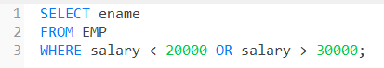

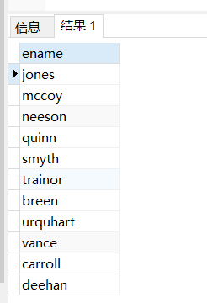

5）

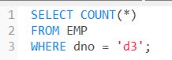

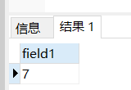

6）

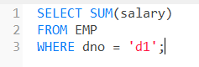

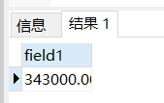

7）

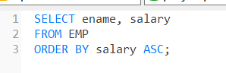

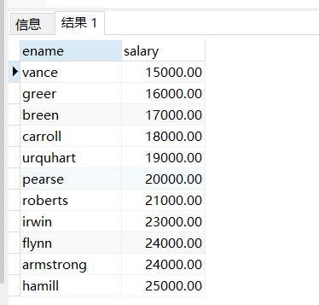

8）

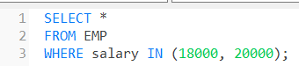

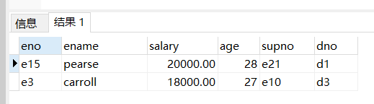

9）

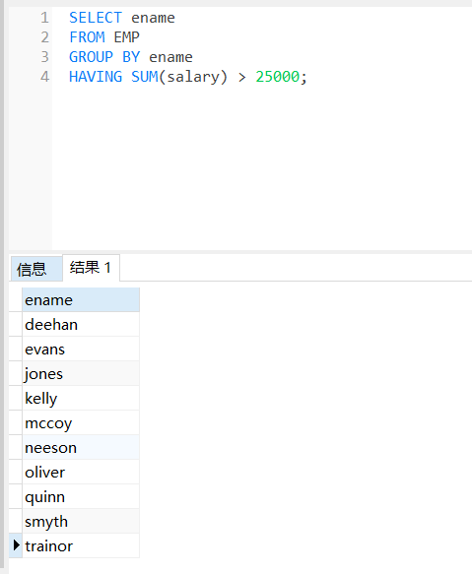

10）

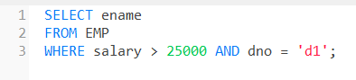

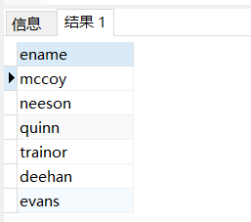

11）

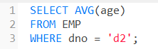

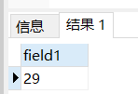

12）

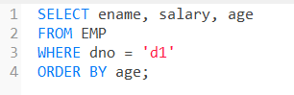

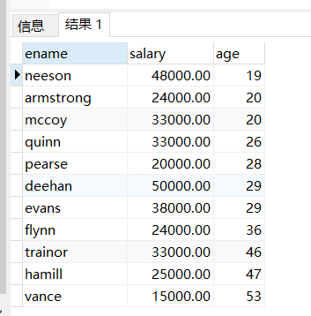

13）

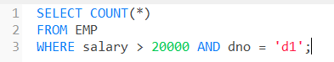

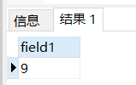

3.2 Debugging analysis

Problems during the debugging process and solutions

Give the program running screenshot

**5. Summary and experience**

**Through this experiment, you learned how to connect a database to the experimental environment and complete a series of query tasks using SELECT statements. Specifically, you have learned the following:**

**How to attach database files to the experimental environment in SQL Server Management Studio (SSMS).**

**How to use the USE statement to select the database to operate on.**

**How to use the SELECT statement to query data in database tables.**

**How to use the WHERE clause to filter query results.**

**How to use the COUNT function to count the number of records.**

**How to use the SUM function to calculate the sum of numerical columns.**

**How to use the ORDER BY statement to sort query results.**

**How to use the IN operator to match multiple values.**

**How to use the AVG function to calculate the average value of a numerical column.**

**These are the basic concepts and techniques commonly used in SQL queries, which can help you further master your abilities in database operations and data analysis. At the same time, the experiment also made you more familiar with the use of SSMS tools, providing basic knowledge for future database development and management.**